Day_3 Date:14/08/2025

Topics:

Selenium

Selenium

**Selenium** is a Python (and multi-language) library for automating browsers.

It lets you **open websites, click buttons, fill forms, scrape data**, and even **test web apps** automatically.

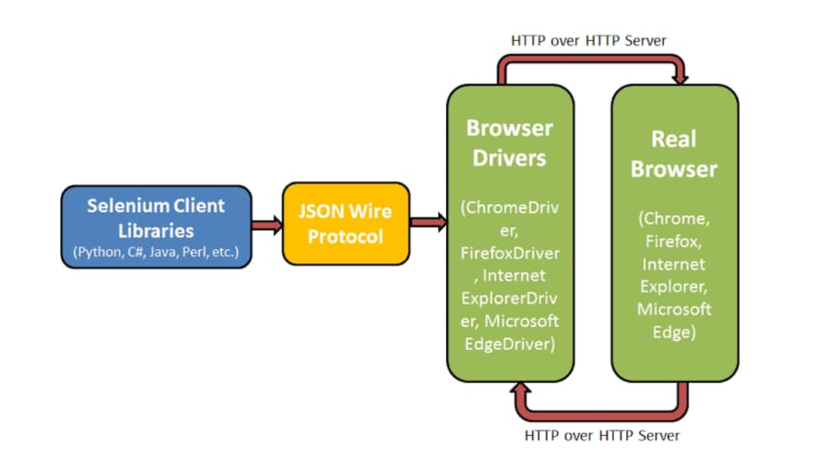

WebDriver

Documentation: <https://www.selenium.dev/documentation/webdriver/>

<https://www.scrapingbee.com/blog/selenium-python/>

WebDriver drives a browser natively, as a user would, either locally or on a remote machine using the Selenium server. It marks a leap forward in terms of browser automation.

* WebDriver is a compact object-oriented API.
* Driver Sessions: <https://www.selenium.dev/documentation/webdriver/drivers/>
* Web Elements: <https://www.selenium.dev/documentation/webdriver/elements/>
* Browser Interaction: <https://www.selenium.dev/documentation/webdriver/interactions/>
* Actions API: <https://www.selenium.dev/documentation/webdriver/actions_api/>

XPath

XPath can be used to navigate through elements and attributes in an XML document.

Ex:

//*[@id="main"]/div[2]/div[1]/div[5]/div[8]/table/tbody/tr[1]

//*[@id="main"]/div[2]/div[1]/div[5]/div[8]/table/tbody/tr[2]

/html/body/main/div[2]/div[1]/div[5]/div[8]/table/tbody/tr[1]—Full XPath

//*[@id="main"]/div[2]/div[1]/div[5]/div[5]/table/tbody/tr[1]

More Info: <https://www.w3schools.com/xml/xpath_examples.asp>

**By class**: Selenium offers multiple locator strategies using the By class

**Elements**: an element refers to a single node in the HTML DOM (Document Object Model) of a web page — usually something like a button, link, text field, image, table cell, etc., that you can interact with. Think of them as Python objects representing HTML tags.

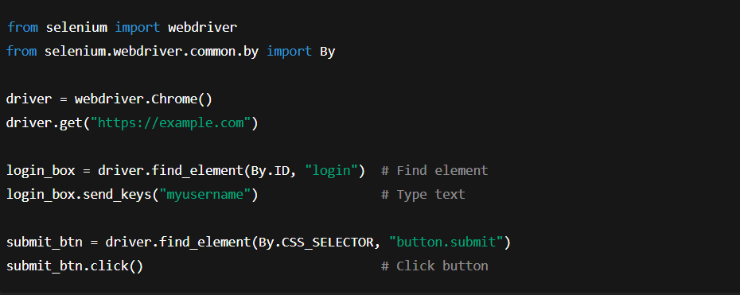

Regex for Web Scraping